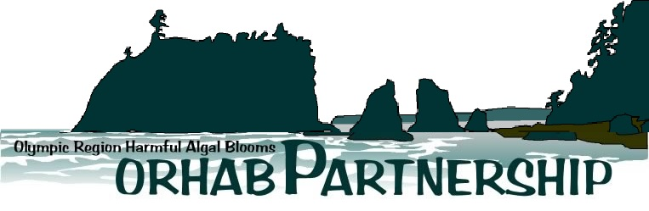

Administrative Office

UW Olympic Natural Resources Center

1455 South Forks Avenue (Hwy 101)

Forks, WA 98331

**DRAFT**: Data Release and Acknowledgment Agreement

Due to a high number of requests for data, we ask that you please fill out the following form and/or attach a separate document or proposal with the appropriate information. **Please sign the last page of this form if you agree to the conditions listed.**

**Data Set Name:** ORHAB Longitudinal Shore Monitoring Data

**Data Set Manager Name:** Rich Osborne ([osborner@uw.edu](mailto:osborner@uw.edu) ) 360-301-2175

## Submitter Information:

**Name(s):** Christopher Free

**Organization:** University of California, Santa Barbara

**Contact Information:** 610-999-4732 | cfree@ucsb.edu

**Date of Request:** September 7, 2021

## Purpose of the Data Use

[*Describe the purpose for which the data will be used. Please be as detailed as possible; you may attach another sheet if needed or descriptive document.*]

We will use the ORHAB data to explore the spatial-temporal dynamics of domoic acid contamination risk during the commercial Dungeness crab fishing season. This will largely involve visualizing the time series of *Pseudo-nitzschia* and particulate domoic acid densities at the sampling sites relative to the season. I have provided example figures made using the similar California HABMAP data below.

**Data Requested**

[*Please be specific about what data you are interested in using (e.g., data fields, dates, locations*)]

I would primarily like the complete time series of *Pseudo-nitzchia* and particulate domoic acid densities at all of the ORHAB beach sampling sites. I suspect that this will have data fields for the following:

* Sampling site name
* Sampling site lat/long
* Sampling date
* Small Pseudo-nitzschia density
* Large Pseudo-nitzschia density
* Particulate domoic acid concentration

I would also like the coordinates (lat/long) for the domain of the LiveOcean Forecast. I do not need to the underlying data. I am just interested in visualizing the coverage of this dataset.

Finally, I would be interested in the offshore sampling data and meta-data on the location of the offshore sampling sites. I suspect this will have similar fields to the beach sampling data.

**Project Timeline**

[*Please describe when you need the data and when deliverables might be expected for your project*]

The project is in the advanced stages of preparation. I anticipate submitting the paper to *Harmful Alga* by October 22, 2021. I would be happy to let the steering committee review the manuscript while the Fish & Wildlife and Public Health Departments review the manuscript, if interested.

Co-author review: Sep 13-24

Address co-author comments: Sep 27-Oct 1

DFW/DPH review: Oct 4-15

Address DFW/DPH comments: Oct 18-22

Submit to *Harmful* Algae: Oct 22

**Plans for publication**

[*If you are considering a peer-reviewed publication, we would like to know your plans, where our data fit into the project, are they integral, and to what degree you would like for ORHAB partners to participate in preparation of this publication?*]

I am planning to publish this data in a peer-reviewed publication to explore the risk of domoic acid contamination in the spring fishing season when domoic acid contamination in crabs is monitored less frequently. The data will most likely be featured in a main text figure but might be featured in supplement. I would describe it as semi-integral. The California data demonstrates that there is late season contamination risk but the addition of the Oregon and Washington data would strengthen this argument. Dr. Vera Trainer of NOAA is a co-author on this paper and is an ORHAB partner.

**--------------------------------------------------------------------------------------------------------------------------**

**Terms of Agreement:**

Use of the requested data shall be limited to the projects specified above. Data may not be used in any other project or distributed to other parties without the approval of a new data release agreement with ORHAB. This dataset may not be displayed on the internet, in any form, without the permission of ORHAB. Peer-reviewed and other publications should include co-authorship where determined appropriate by both parties. In cases where co-authorship is not warranted, acknowledgement for the data should be cited as "We thank ORHAB and its member partners for providing data used in this manuscript."

**Ownership of Items Produced as a result of this data:**

All writings, programs, analyses, art work, music, maps, charts, tables, illustrations, records or other written, graphic, analog or digital materials prepared by the signatories, in connection with the use of this data shall be the sole and absolute property of the signatories without dispute as long as ORHAB and its data set are acknowledged (as previously agreed upon) in all associated reference citations and graphic captions where the data is used. The signatories also agree to provide, in accordance with customary standards, the appropriate acknowledgement in any such publication of ORHAB support or other role in the project.

**Publication and Acknowledgement of Data User products by**:

ORHAB reserves the right to make or permit to be made scholarly disclosures of the results of the Project, including without limitation, publication in scholarly journals, presentations at academic and other conferences, disclosures to ORHAB and non-ORHAB scholars, and disclosures in grant and funding applications. ORHAB agrees to provide, in accordance with customary standards, an appropriate acknowledgement in any such publication of Sponsor’s support or other role in the Project.

### Reviewed and approved by:

**Data Requestor/Submitter:**

[PRINT]

______________________________________________________ _________________

[SIGN] [DATE]

**ORHAB Administrative Coordinator (**On behalf of the ORHAB Steering Committee):

_________________________________________________ ____________________

[SIGN] [DATE]

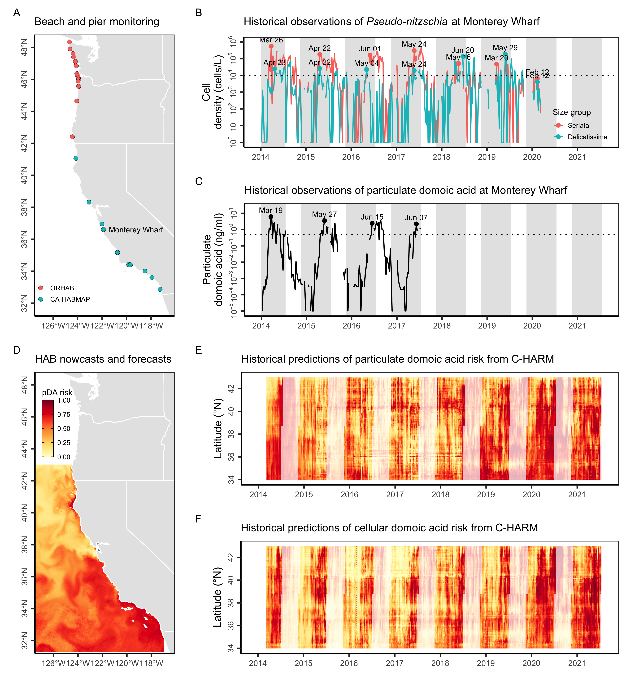

**Example Figure 1.** Historical indicators of potential mid-season domoic acid risk in the commercial California Dungeness crab fishery. Panel (A) shows the location of historical Pseudo-nitzschia and particulate domoic acid monitoring at piers and beaches along the West Coast. Panels (B) and (C) show historical Pseudo-nitzschia and particulate domoic acid densities, respectively, at Monterey Wharf in California. In (B), colored lines indicate the density of Pseudo-nitzschia in the smaller ‘delicatissima’ (<3 μm valve width) and the larger and more toxigenic ‘seriata’ (>3 μm valve width) size classes; the dotted black line indicates the 10,000 cells/L bloom threshold used by C-HARM. In (C), the dotted black line indicates the 0.5 ng/ml threshold for elevated pDA risk used by C-HARM. In both panels, the grey shading indicates the commercial Dungeness crab fishing season and the labels mark in-season peaks in HAB risk. Panel (D) illustrates an example prediction of particulate domoic acid (pDA) risk from C-HARM. Panels (E) and (F) illustrate mean daily particulate domoic acid and cellular domoic acid risk, respectively, within Dungeness crab fishing grounds (<100 fathoms) along 3-km latitudinal bands. In both panels, non-transparent hues indicate the commercial Dungeness crab fishing season.

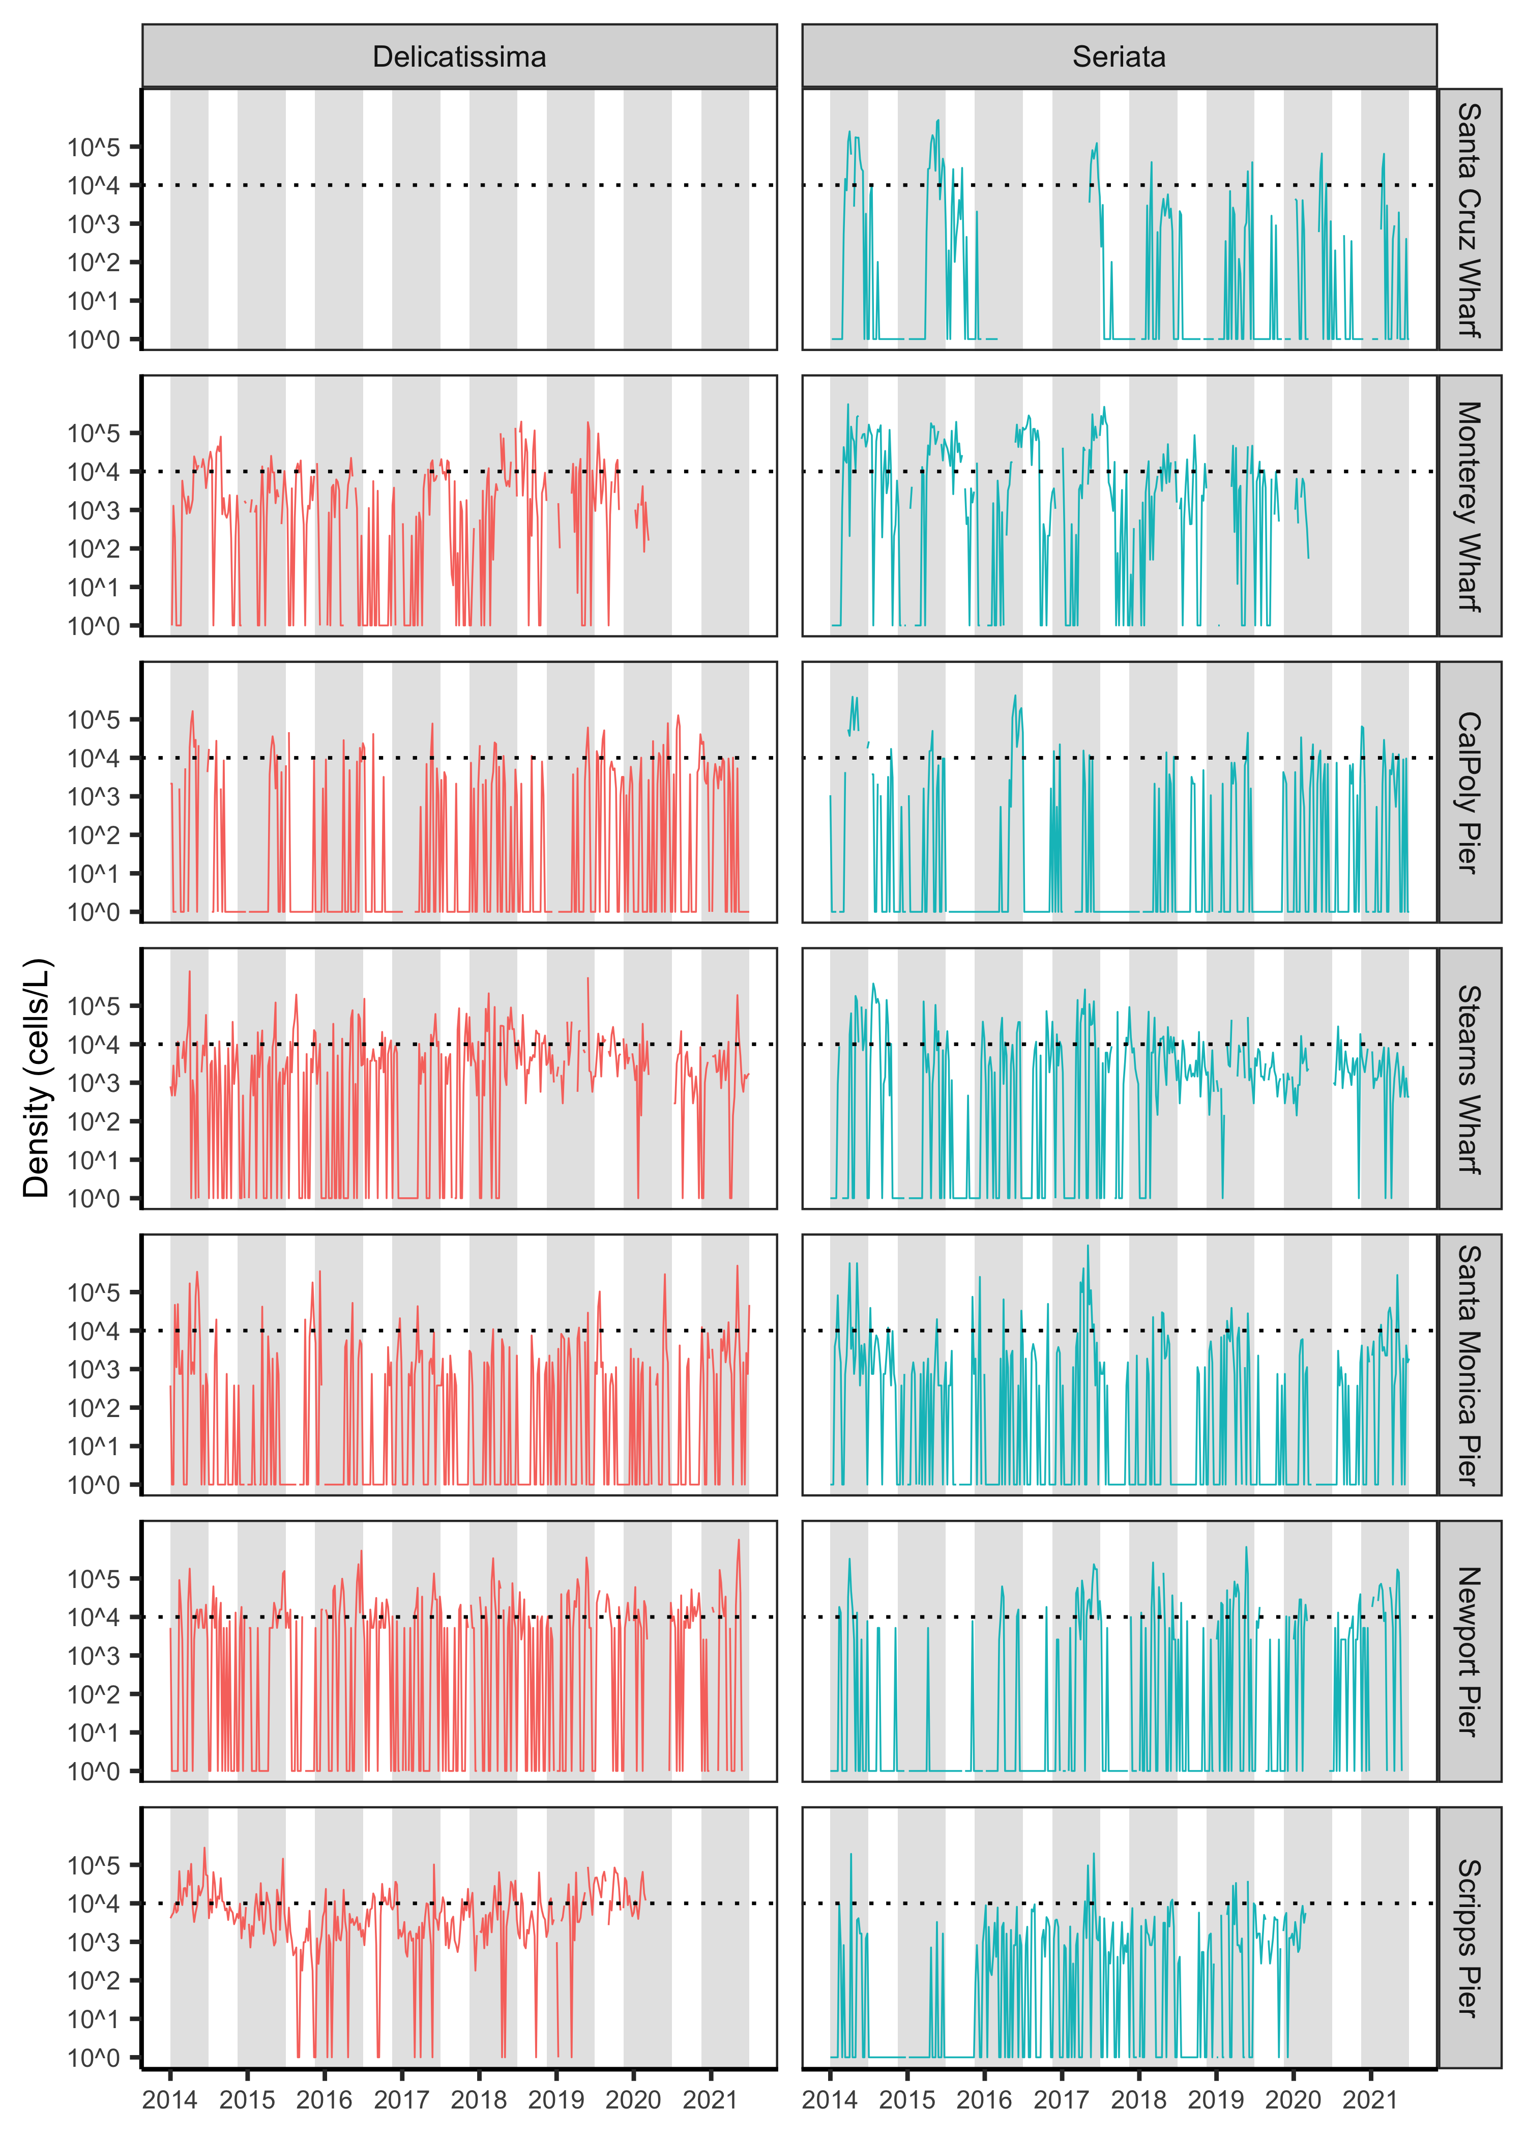

**Example Figure 2.** Weekly density of *Pseudo-nitzschia* in the smaller ‘delicatissima’ (<3 μm valve width) and larger ‘seriata’ (>3 μm valve width) size classes [(Bowers et al., 2018)](https://www.zotero.org/google-docs/?trtpJA)at seven piers in California from 2014-2021. *Pseudo-nitzschia* in the seriata size class are considered more toxigenic. The dotted horizontal lines indicate the 10,000 cells/L bloom thresholds of [(Anderson et al., 2011)](https://www.zotero.org/google-docs/?JwW09o). Grey shading indicates the commercial Dungeness crab fishing season in the central region. Piers are ordered from north to south. Data from Trinidad Pier and Goleta Pier are publicly available from SCCOOS but are not plotted due to their limited temporal coverage. Data are collected from Bodega Bay but are not publicly available.